Visual Argument
Student Name
Institution Affiliations
Date

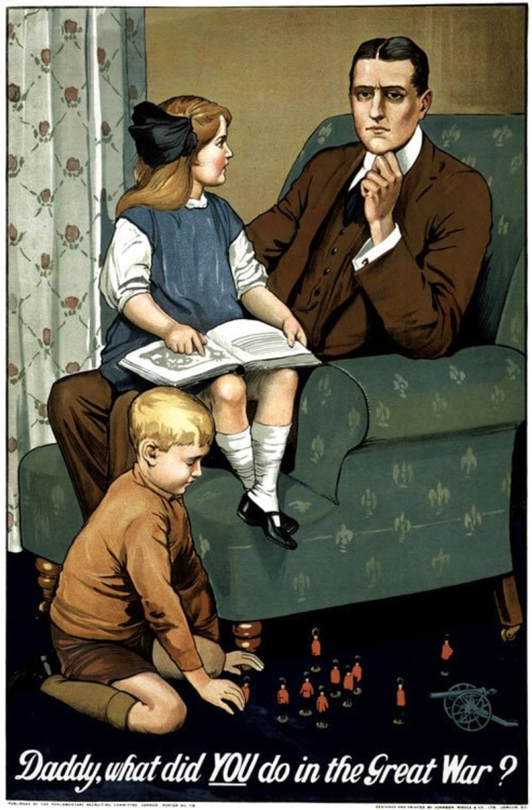
This is an image of a man sitting on a chair, on his laps, his daughter reading a book, and on the floor, his son who is playing with toys. The image is obtained online from a web page referenced https://static-cse.canva.com/blob/135186/02.297fb426.jpg. It was created by Savile Lumley, a British illustrator. His objective was to induce family men to enroll in military training so that they can help to fight a world war. This is evident from the picture that portrays a boy happily playing on the floor with what seems to be toys of soldiers and war canon, the girl is asking or showing something on the book to the father, and the pictorial set up of the family appears happy; well-arranged house and the family is well-dressed. Also, the image creator through the children’s voice asks, “Daddy, what did YOU do in the great war?” The children are proud of their father's contribution to the war. The setup and context of the image produce a convincing effect on the viewer. Lumley's aim of the poster was to strike the pride of family men and persuade them to join the military camps. Additionally, they would not be judged by their families for neglecting them, but instead, they will be praised in their wartime. In conclusion, the author tries to convince people to believe that the military is not a dangerous place as people believe it to be, and soldiers can have happy and successful family lives as well. Youth and family men can therefore join the military and enjoy their future lives after wars.

